**Physics**

**Paper 1**

**Sample paper 2021**

**2 hours**

LOGO

UGANDA NATIONAL EXAMINATIONS BOARD

Uganda Certificate of Lower Secondary Education

Physics

Paper 1

2 hours 30 minutes

**CANDIDATE NAME: __________________________________________________**

**CANDIDATE NUMBER: ________________________________________________**

**CENTRE NUMBER: ___________________________________________________**

**THIS PAGE IS FOR EXAMINER USE ONLY**

Do not write in the boxes on this page. The examiner will use them to keep a record of your marks.

|  |  |  |  |  |  |  |  |  |  |  |  |  |  |  |  |  |  |  |  |  |
| --- | --- | --- | --- | --- | --- | --- | --- | --- | --- | --- | --- | --- | --- | --- | --- | --- | --- | --- | --- | --- |
| **SECTION A** |  |  |  |  |  |  |  |  |  |  |  |  |  |  |  |  |  |  |  |  |
| Qn | **1** |  | **2** |  | **3** |  | **4** |  | **5** |  | **6** |  | **7** |  | **8** |  | **9** |  | **10** | **Total** |
|  |  |  |  |  |  |  |  |  |  |  |  |  |  |  |  |  |  |  |  |  |
| Max marks | 4 |  | 4 |  | 4 |  | 4 |  | 4 |  | 4 |  | 4 |  | 4 |  | 4 |  | 4 | 40 |
|  |  |  |  |  |  |  |  |  |  |  |  |  |  |  |  |  |  |  |  |  |
| Actual marks |  |  |  |  |  |  |  |  |  |  |  |  |  |  |  |  |  |  |  |  |
| **SECTION B** |  |  |  |  |  |  |  |  |  |  |  |  |  |  |  |  |  |  |  |  |
| Qn | **11** |  | **12** |  | **13** |  | **14** |  | **15** |  | **16** |  |  |  |  |  |  |  |  | **Total** |
|  |  |  |  |  |  |  |  |  |  |  |  |  |  |  |  |  |  |  |  |  |
| Max marks | 15 |  | 15 |  | 15 |  | 15 |  | 15 |  | 15 |  |  |  |  |  |  |  |  | 60 |
|  |  |  |  |  |  |  |  |  |  |  |  |  |  |  |  |  |  |  |  |  |
| Actual marks |  |  |  |  |  |  |  |  |  |  |  |  |  |  |  |  |  |  |  |  |
|  |  |  |  |  |  |  |  |  |  |  |  |  |  |  |  |  |  |  |  |  |

**INSTRUCTIONS TO CANDIDATES**

1. This paper consists of two sections; Section A and Section B.
2. Section A consists of 12 structured questions. Attempt **all questions** in this section by filling the answers in the spaces provided.
3. Section B consists of six extended short essay questions. Attempt **any four** questions from this section. Answers to questions in this section must be written on separate booklets provided. All questions in this section carry equal marks

**Section A (40 mks)**

1. A heap of weed of mass 3 tonnes is moving towards the turbines at the Jinja power station. A group of engineers needs to use a machine operating at 20 kW for five minutes, to remove the weed from the river as shown in Figure and place it at the bank, which is 15 m above the river.

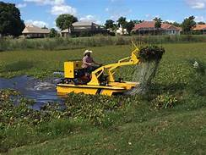

Figure 1

1. Determine the efficiency of the machine. (3 marks)

……………………………………………………………………………………………………………………………………………………………………………………………………………………………………

1. Comment on the efficiency of the machine. (1 mark)

………………………………………………………………………………………………………………………..

1. On a hot day, a student dropped three ice cubes at -6 oC in a jug of water at room temperature. If the final temperature of the mixture after all the ice has melted was 16 oC,
2. Sketch a temperature-time graph for the ice. (1 mark)
3. Describe the key features of your graph in (i) above. (3marks)

……………………………………………………………………………………………………………………………………………………………………………………………………………………………………………………………………………………………………………………………………………………………..

1. A car of mass 1200 kg travelling at 15 m s–1 comes to rest over a distance of 30 m. Find;
2. The average retardation (2 marks)

……………………………………………………………………………………………………………………………………………………………………………………………………………………………………………………………………………………………………………………………………

1. The average breaking force. (2 marks)

…………………………………………………………………………………………………………………………………………………………………………………………………………………………………………………………………………………………………………………………………………….

1. During a thunderstorm, a certain farmer’s cow that was sheltering under a tall tree was struck by lightning and it fell dead as shown in Figure 2.

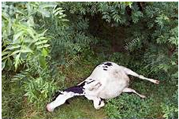

Figure 2

His village mates attributed this incidence to witchcraft. As a Physics student, explain to the villagers how lightning is caused and that the incident was not induced by witchcraft. (4 marks)

……………………………………………………………………………………………………………………………………………………………………………………………………………………………………………………………………………………………………………………………………………………………………………………………………………………………………………………………….

1. A geostationary satellite is used by a certain commercial company to relay Premier League matches around the globe. If the altitude of a circular geostationary orbit is 35,800 km and the radius of the earth is 6,400 km,
2. Determine the distance moved by the satellite during one complete revolution. (2 marks)

……………………………………………………………………………………………………………………………………………………………………………………………………………………………………………………………………………………………………………………………………………………………………….

1. Find the speed of the satellite in its orbit. (2 marks)

………………………………………………………………………………………………………………………………………………………………………………………………………………………………………………………………………………………………………………………………………………………………………………………………………………………………………………….

1. A ship sends an ultrasonic sound wave to the seabed to determine the depth of the sea. The echo of the ultrasonic sound wave is received after 1.2 ms.
2. What is the name of the phenomenon being applied in this case? (1 mark)

………………………………………………………………………………………………………………………………………………………………………………………………………………………………………………

1. If the speed of ultrasonic sound waves in sea water is 2 ×106 m s–1, what is the depth of the sea?(3 marks)

……………………………………………………………………………………………………………………………………………………………………………………………………………………………………………………………………………………………………………………………………………………………………………………………………………………………………………………………….

1. A head teacher instructed the school carpenter to make a notice board of dimensions 1.5 m by 0.5 m. If each notice is written on a piece of paper of dimensions 21 cm by 30 cm, what is the maximum number of notices that can be put on the notice board at any one time? (4 marks)

…………………………………………………………………………………………………………………………………………………………………………………………………………………………………………………………………………………………………………………………………………………………………………………………………………………………………………………………………………………………………………………………………………………………………………………………………….

1. Kato is a committed tailor. When she has pressure from her customers, she makes clothes very fast, but when there is less pressure from the customers, she makes the clothes slowly. It is noticed that when she presses on the pedal once, the needle prints five times and the distance between successive prints is 1 cm. For her to make a hem of a skirt, she presses on the pedal after every 2 s, 20 times. Determine;
2. The length of the hem. (2 marks)

…………………………………………………………………………………………………………………………………………………………………………………………………………………………………………………………………………………………………………………………………………………………..

1. The time taken to complete the hem. (2 marks)

…………………………………………………………………………………………………………………………………………………………………………………………………………………………………………………………………………………………………………………………………………………………….

1. A plumber noticed that the bath in Etomet’s home was not functioning satisfactorily because the water pressure at the showerhead shown in Figure 4was too low.

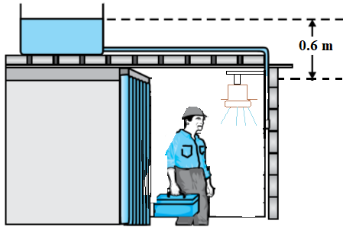

Figure 4

Taking density of water = 1000 kg m–3, g= 10 N kg–1,

1. What is the water pressure at the showerhead? (2 mks)

………………………………………………………………………………………………………………………………………………………………………………………………………………………………….

1. What must the plumber do to increase the water pressure at the showerhead to 15,000 Pa? (2mks)

………………………………………………………………………………………………………………………………………………………………………………………………………………………………………………………………………………………………………………………………………………………

1. On a certain sunny day, a taxi driver saw a pool of water ahead on a tarmac road as he was driving as shown in Figure 5.

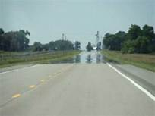

Figure 5

To his surprise, the pool disappears as he approaches it. With the aid of an appropriate ray diagram, explain the taxi driver’s surprise. (4mks)

**Section B**

1. (a) Kalindi was puzzled that the shallow end of the swimming pool at his school appeared to be about 1.5 m deep when in the actual sense it was 2.0 m.
2. Use a ray diagram to illustrate Kalindi’s puzzle. (4 marks)
3. Use your ray diagram above to explain to Kalindi why the swimming pool appeared shallower than it actually is. (4 marks)

(b) A barber was given a curved mirror of focal length 30 cm so that he could use it as a shaving mirror in his salon.

1. Identify the type of curved mirror given to the barber. (1 mark)
2. Use a ray diagram to illustrate the use of the selected curved mirror as a shaving mirror. (4 marks)
3. What are the properties of the image formed above? (2 marks)
4. One of the most important components of our solar system is the sun. Another important component of our solar systems are the big masses called planets.
5. Name all the planets found in our solar system. (4 marks)
6. i. Identify the planet that sustains life in our solar system. (1 mark)

ii. How are the times and seasons of the year explained on the planet mentioned in (b) (i) above? (5 marks)

1. Explain the statement that “the sun has a life cycle”. (5 marks)
2. (a) Using a diagram, describe an experiment, which can help you to categorize the following materials as electric conductors or insulators: copper, wood, plastic, iron, aluminium, graphite, rubber, cardboard, glass, wool. (5marks)
3. Four similar bulbs, P, Q, R and S are connected in a circuit as shown in Figure 6.

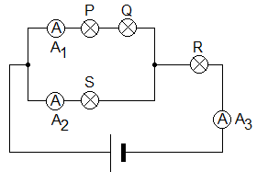

Figure 6: An electric circuit

1. Which bulb(s) will light the brightest? (1mark)
2. If ammeter A1 reads 1.5 A and ammeter A2 reads 2.0 A, what is the reading on ammeter A3? Explain your answer. (2marks)
3. Explain why domestic appliances are arranged in parallel. (2marks)
4. Calculate the total resistance when three resistors of values 2Ω, 5 Ω and 10 Ω are connected in
   * + 1. Series. (2marks)
       2. Parallel and comment on your answer. (3marks)
5. Figure 7 shows the arrangement of apparatus by a learner to investigate the relationship between the mass of lead shots, m, and the immersion depth, h, of the cylinder. The learner placed different masses of lead shots in the cylinder and measured the corresponding immersion depths. A graph of immersion depth, h, against mass of lead shots, m, was then drawn as shown in Figure 8.

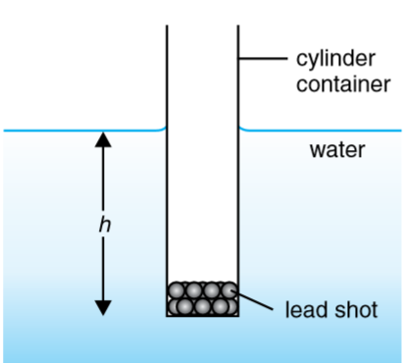 Figure 7 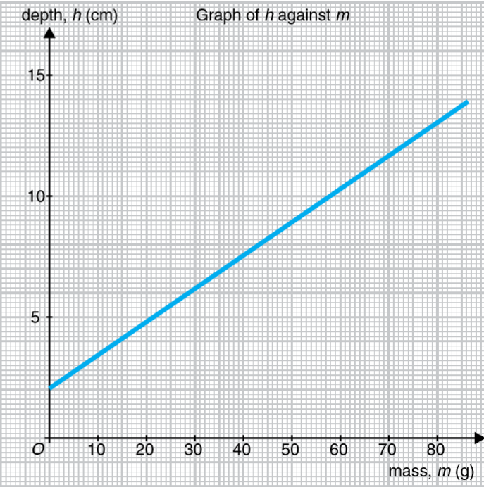 Figure 8

(a) Based on the graph in Figure 8,

(i) state the relationship between m and h. (2 marks)

(ii) what is the value of h, if the cylindrical container is empty? (2 marks)

(iii) calculate the gradient of the graph. (4marks)

(b) (i) Using the value of the gradient of the graph obtained in (a)(iii) and the relationship, $A=\frac{1}{Gradient}$, where A is the cross-sectional area of the cylindrical container, in cm2, calculate the value of A. (2 marks)

(ii) Find the volume of the water displaced when 50 g of the lead slots are added into the cylinder. (3 marks)

(c) Identify one principle in Physics connected with this experiment. (1 mark)

(d) State one precaution to be taken when conducting this experiment. (1 mark)

1. (a) In order to construct a p-type semiconductor or n-type semiconductor, a doping process is performed on a pure silicon crystal. When a p-type semiconductor is combined with an n-type semiconductor, a diode is formed which acts as a rectifier.
2. What do you understand by the term “doping”? (1 mark)
3. Explain how a p-type semiconductor material is made. (2 marks)

(b) (i) Draw a circuit diagram showing the arrangement of four diodes used as a full-wave rectifier. (2 marks)

(ii) Explain how the full-wave rectifier works and sketch the output wave. (5 marks)

1. The combination of logic gates in Figure 9is suggested for use in a certain logic system.

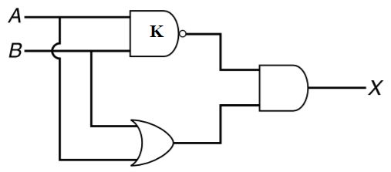

Figure 9

1. Name the logic gate K. (1 mark)
2. Construct the truth table to determine output X. (4 marks)
3. (a) Heat generated in the car engine has to be removed, effectively using a liquid in the car cooling system to avoid overheating. Table 1 shows the characteristics of some of the liquids used in the cooling system.

Table 1

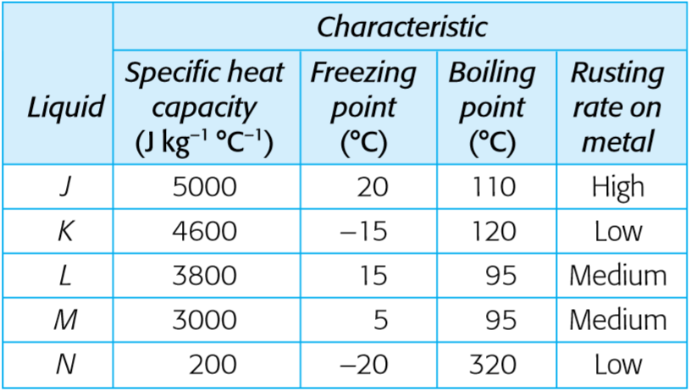

1. What is the important of a cooling system in a car? (2 marks)
2. With reference to Table 1, which liquid is most suitable to be used in the cooling system? Justify your choice. (5 marks)

(b) Figure 10 shows a graph of temperature plotted against time for 0.8 kg of a pure substance, which is being heated at a constant rate over the range from –20 °C to 60 °C.

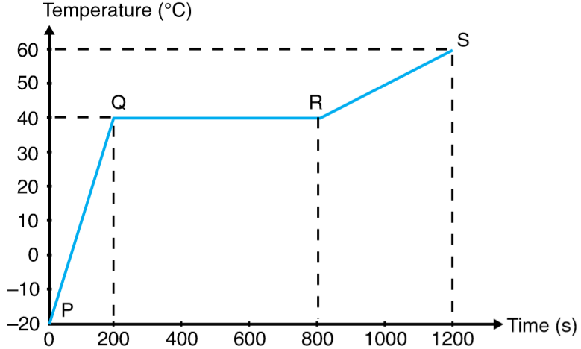

Figure 10

The specific heat capacity of the substance is known to be 1000 J kg–1 °C–1 when it is in the liquid state. Assume no heat is lost from the apparatus and the heat capacity of the vessel is negligible.

1. Using the kinetic theory of matter, explain why there is no increase in temperature in the region QR even though the substance is heated. (2 marks)
2. Calculate the specific latent heat of fusion of the substance. (6 marks)

***END***

**THE LOWER SECONDARY CURRICULUM**

## 5.3 PHYSICS PAPER 1 MARKING GUIDE

The mark scheme for each question shows:

* the marks available for each part of the question
* the total marks available for the question
* the typical response or responses which are expected
* extra information to help the examiner make his or her judgment and help to delineate what is acceptable or not worthy of credit or, in extended responses, to give an overview of the area in which a mark or marks may be awarded.

The extra information is aligned to the appropriate answer in the left-hand part of the mark scheme and should only be applied to that item in the mark scheme. Note the following:

* In a list of acceptable answers where more than one mark is available, ‘**any two from**’ is used, with the number of marks emboldened.
* The phonetic spelling of correct scientific terminology should be **credited** unless there is a possible confusion with another technical term.
* Ignore / Insufficient / Do not allow: “Ignore” or “insufficient” are used when the information given is irrelevant to the question or not enough to gain the marking point. Any further correct amplification could gain the marking point. “Do not allow” means that this is a wrong answer which, even if the correct answer is given as well, will still mean that the mark is not awarded.
* For numerical items, award the marks even if the unit is not provided, unless the item so demands.
* **In a competence-based assessment, half a score is not awarded. It’s either a score for a competence exhibited or no score for no competence exhibited.**

**Section A**

|  |  |  |  |  |  |
| --- | --- | --- | --- | --- | --- |
| **Item Number** | | | **Responses** | **Scoring criteria** | |
| 1. |  | i. | - Mass, m = 30 tonnes = 30,000 kg,  - machine power, P = 20 kW =20,000 W,  - time, t = 5 min = 300 s,  - height, h = 15 m.  - Work output, Wo = mgh = 30,000x10x15 = 4,500,000 J.  - Work input, Wi = Pt = 20,000x300 = 6,000,000 J.  - $Efficiency=\frac{W_{o}}{W_{i}}×100=\frac{4500000}{6000000}×100=75\%$. | - Award 1 if all quantities are expressed in their correct SI units.  - Award 1 for correct substitution in the expression for calculating efficiency.  - Award 1 for the correct answer even without percentage. | |
| ii. | Since the efficiency is less than 100%, some input energy is being wasted to perform work against friction instead of overcoming the load. | * Award 1 if mention is made of energy wastage by the machine. | |
| 2. |  | i. |  | * Award 1 mark if shape of graph is correct and the vertical axis is correctly labeled. | |
| ii. | * Between A and B, the temperature of ice is rising because it is gaining specific heat capacity of ice from the water in the jug. * Between B and C, the ice is melting at constant temperature by gaining latent heat of fusion from the water in the jug. * Between C and D, the temperature of the molten ice is rising because it is gaining specific heat capacity of water from the water in the jug to raise its temperature to 16 oC. | * Award 1 mark for correct description of each feature of the graph to make a total of 3 marks | |
| 3. |  | i. | From  m s-2 (negative sign implies retardation) | * Award 1mark for correct formula. * Award 1 mark for correct retardation | |
| ii. | * From F = ma = 1200 x -3.75 = -4,500 N. | * Award 1 mark for correct formula. * Award 1 mark for correct retarding force. | |
| 4. |  |  | * During a thunderstorm, the random movement of clouds causes them to rub against each other. Hence, they acquire electric charges by friction. * The positive hydrogen ions rise higher to the sky due to their less weight while the negative hydroxyl ions remain attached to the lower clouds. * When the negatively charged clouds collide, they produce sparks by releasing high electron currents, which find their way to the earth through high points on the earth’s surface. * Hence, if the cow is sheltering under a tall tree, the tree provides a short route for the electrons to the earth. The high electron currents will therefore pass through the cow, killing it instantly. | * Award 1 mark if the learner explains that the clouds get charged by friction. * Award 1 mark if the learner identifies the lower clouds to acquire negative charge. * Award 1 mark if the learner explains how the high electron current is produced. * Award 1 mark if the learner can identify a tall tree as a sharp point through which the discharged high electron current flows to the earth, causing the death of the cow. | |
| 5. |  | i. | - Altitude, h = 35,800 km  - Radius of earth, R = 6,400 km  - Radius of orbit, r = h+R = 35,800 + 6,400 = 42,200 km  - Distance moved, d = 2πr = 2x3.14x42,200 = 265,016 km | - Award 1 mark if the radius of the satellite is correctly identified.  - Award 1 mark if the circumference of the orbit is correctly calculated. | |
| ii. | * Period of satellite, T = 24 h * Speed, km h-1 | * Award 1 mark if the learner correctly identifies the period of the satellite as 24 h * Award 1 mark if the speed of the satellite is correctly computed, including the correct unit. | |
| 6. |  | i | * Reflection of sound waves | * Award 1 mark for correctly identifying the phenomenon. | |
|  |  | ii | * From 2d = vt $d=\frac{vt}{2}=\frac{2×{10}^{6}×1.2×{10}^{-3}}{2}=1.2$* km. | * Award 1 mark for correct formula. * Award 1 mark for correctly calculated depth of sea. | |
| 7. |  |  | * Area of notice board, A1 = lw = 1.5 x 0.5 = 0.75 m2. * Area of paper, A2 = lw = 0.21 x 0.30 = 0.063 m2. * Ratio = * Number of paper that can fit in the notice board = 11 | * Award 1 mark for correctly calculated area of notice board. * Award 1 mark for correctly calculated area of paper. * Award 1 mark for correctly calculated ratio. * Award 1 mark for correctly identifying that only 11 pieces of paper can fit in the notice board. | |
| 8. |  | i. | - Length covered in each pedal = 4 x 1 = 4 cm  - Length of hem = 4 x 20 = 80 cm | - Award 1 mark for correctly calculated length for each pedal.  - Award 1 mark for correctly calculated length of hem | |
| ii. | * Time between successive pedals = 2 s. * Time to complete the hem = 2 x 20 = 40 s | * Award 1 mark identifying that there are 20 steps of length each taking 2 s. * Award 1 mark for correctly calculating the length of the hem. | |
| 9. |  | i. | - h = 0.6 m, ρ = 1000 kg m-3, g = 10 m s-2.  - Water pressure, P = hρg = 0.6 x 1000 x 10 = 6,000 Pa | - Award 1 mark for correct formula and correct substitution into the formula.  - Award 1 mark for correctly calculated showerhead pressure. | |
| ii. | $h=\frac{P}{ρg}=\frac{15000}{1000×10}=1.5$* m * The water head should be raised by; 1.5 – 0.6 = 0.9 m. | * Award 1 mark for correctly calculated new required height of water head. * Award 1 mark for correctly identifying that the water head should be raised by 0.9 m. | |
| 10. |  |  | * The different layers of air above the earth’s surface have varying densities, which increase with height above the earth. Therefore, as a ray of light travels from a point in the sky, it is continually refracted away from the normal, making it to gradually bend upwards. * Since the tarmac road acts as a reflecting surface, the driver sees the image of the sky in the tarmac road. * When the rays that undergo total internal reflection do not reach the driver’s eyes, the pool of water (image of the sky) disappears. | * Award 1 mark for correct diagram. * Award 1 mark for correct description of the densities of the different layers of air above the earth **and** the effect of this to the propagation of a ray. * Award 1 mark for stating that the pool of water observed is the image of the sky. * Award 1 mark for stating that the pool water disappears because the rays that were undergoing total internal reflection are no longer reaching the eyes of the driver. | |
| **SECTION B** | | | | | |
| 11. | a. | i. |  | | * Award 1 mark for a ray from the actual bottom, O, of the pool to the observer. The ray must be refracted at N away from the normal. * Award 1 mark for correct extrapolation of IN to meet the normal OM. * Award 1 mark for correct identification of IM as apparent depth of pool. * Award 1 mark for correct identification of OM as real depth of pool. |
| ii. | * A ray, ON, from the bottom of the pool is refracted away from the normal at N as it travels to the observer’s eye because air is optically less dense than water. * To the observer, the ray at N appears to come from I, the apparent position of the bottom of the pool. * Therefore, to the observer, the depth of the pool is IM when in the actual sense the depth of the pool is OM. * The observer therefore sees the pool shallower than it actually is. | | * Award 1 mark for correct drawing of the ray from point O to the eye. * Award 1 mark for correct extrapolation of the line NI. I should be vertically above O. * Award 1 mark for correctly identifying IM and OM as apparent depth and real depth of the swimming pool. * Award 1 mark for clear conclusion. |
| b. | i. | - Concave mirror | | - Award 1 mark for correctly identifying the type of curved mirror. |
| ii. |  | | Award 1 mk for position of object between F and P  Award 1 mk for upright magnified image  Award 1 mk for two rays with arrows  Award 1 mk for positions of C, F and P. |
| iii. | * It is magnified. * It is upright. * It is virtual. | | * Award 1 mark each for any two properties mentioned to make a total score of 2 marks. |
| 12, | a. |  | * Inner planets; Mercury, Venus, Earth and Mars * Outer planets; Jupiter, Saturn, Neptune and Uranus | | * Award 1 mark for correct mention of any planet in our solar system. However, a maximum of 2marks should be awarded for two inner planets and likewise a maximum of 2 marks for 2 outer planets. |
|  | b. | i. | - Planet Earth | | - Award 1 mark for correctly mentioning planet earth. |
|  |  | ii. | * Time is explained on planet earth by its rotation about its axis and its revolution around the Sun. * The rotation of the earth about its axis and its revolution about the Sun define time in terms of its different units. * The seasons of the earth are explained in terms of the tilt of the earth. * As the earth rotates about its axis, the tilt causes the overhead position of the Sun to move gradually from the tropic of capricon to the tropic of cancer and vice versa. * This movement of the overhead Sun results in the different seasons of the earth. | | * Award 1 mark for correctly mentioning rotation and revolution of the earth. * Award 1 mark for correctly explaining determinants of time. * Award 1 mark for correctly mentioning relation between the tilt and seasons on earth. * Award 1 mark for correctly identifying changes in the overhead position of the Sun on earth. * Award 1 mark for correctly linking the changes in the overhead position of the Sun resulting in the different seasons on earth. |
|  | c. |  | * The Sun is a star, usually born out of a stellar nebula (a massive collection of dust particles in the universe). * After acquiring a critical mass and sufficient gravity, it develops into a massive star by nuclear reactions of the constituent gasses. * After many years of nuclear radiations and emissions, the massive star will explode into a super red giant when the gravitational force can no longer hold the particles together. * The super red giant will undergo further explosion into a supernova, with a very bright central part. * Finally, the supernova will end up into either a neutral star or a black hole, which will be the last stages in the life cycle of the Sun. | | * Award 1 mark for identifying that the sun originates from stellar nebula * Award 1 mark for stating that the sun develops into a massive star by nuclear reactions * Award 1 mark for identifying that the massive star explodes into a super red giant because gravitational force is no longer sufficient to hold the particles together * Award 1 mark for mentioning that the super red giant will undergo further explosion into a supernova * Award 1 mark for stating that the supernova will end up into either a neutral star or a black hole, |
| 13. | a. |  | The circuit above is connected with switch K open. The copper material is connected across XY and then the switch K is closed. The bulb B will be seen to light. Open switch K and remove the copper material from the gap XY. Repeat the procedure for the rest of the materials and observe whether the bulb lights or not. Materials for which the bulb lights are conductors while those for which the bulb does not light are insulators. | | * Award 1 mark for correct circuit diagram. * Award 1 mark for correct explanation of the use of the gap XY. * Award 1 mark for the correct description of the use of the switch K. * Award 1 mark for the correct explanation of the use of the bulb in the circuit. * Award 1 mark for the correct deductions made. |
|  | b. | i. | - Bulb R will light the brightest. | | - Award 1 mark for correctly identifying R |
|  |  | ii. | * Reading of A3 = 1.5 + 2.0 = 3.5 A * The effective current in a parallel connection is the algebraic sum of the currents in the different branches of the circuit. | | * Award 1 mark for correct reading of A3 * Award 1 mark for identifying that the effective resistance in series is obtained by addition. |
|  | c. |  | * Domestic appliance are arranged in parallel so that their effective resistance is low and a failure of current flow in one branch will not affect the other branches. | | * Award 1 mark for mention of low effective resistance. * Award 1 mark for mention independence of the different branches. |
|  | d. | i. | - Total resistance in series; R = R1 + R2 + R3 = 2 + 5 + 10  Therefore, R = 17 Ω | | * Award 1 mark for expression of addition. * Award 1 mark for correct value of R |
|  |  | ii. | * Total resistance in parallel; $\frac{1}{R}=\frac{1}{R_{1}}+\frac{1}{R_{2}}+\frac{1}{R_{3}}=\frac{1}{2}+\frac{1}{5}+\frac{1}{10}$* Therefore, $\frac{1}{R}=\frac{8}{10}$ implying that $R=\frac{10}{8}=1.25$ Ω * The effective resistance is lower than any of the resistors in the arrangement. | | * Award 1 mark for expression of effective resistance. * Award 1 mark for correct value of R. * Award 1 mark for correct explanation. |
| 14. | a. | i. | - h = a +bm, where a is a constant and b is the gradient of the graph. | | - Award 1 mark for correct relation.  - Award 1 mark for explain the terms a and b. |
|  |  | ii. | * 2 cm when m = 0. | | * Award 1 mark for correctly reading the value of h. * Award 1 mark for the correct unit of h. |
|  |  | iii. | * Gradient = cm g-1. | | * Award 1 mark for correct expression for gradient. * Award 1 mark for correctly reading the values used for gradient calculation. * Award 1 mark for the correct value of gradient. * Award 1 mark for the correct unit of gradient. |
|  | b. | i. | - cm2. | | - Award 1 for correct substitution in the expression for A.  - Award 1 mark for correct value of A. |
|  |  | ii. | * cm3. | | * Award 1 mark for correct formula. * Award 1 mark for correct substitution in the formula. * Award 1 mark for correct volume. |
|  | c. |  | * Principle of floatation i.e. A floating body displaces its own weight of the fluid in which it is floating. | | * Award 1 mark for correct statement of the principle used. |
|  | d. |  | * Ensure that the cylinder is upright. * The water surface should be still (calm) | | * Award 1 mark for any one of the precautions correctly stated. |
| 15. | a. | i. | - Doping is the addition of impurities in a pure semiconductor in order to improve on the electrical conductivity of the semiconductor. | | - Award 1 mark for correctly defining the term doping. |
|  |  | ii. | * A p-type semiconductor material is made by using a trivalent material. The three valence electrons of the impurity material form covalent bonds with three valence electrons of the semiconductor material. This exposes a positive charge in the semiconductor material. | | * Award 1 mark for mention of use of a trivalent impurity. * Award 1 mark for correctly explaining the covalent bonding process. |
|  | b. | i. |  | | * Award 1 mark for correctly indicating the terminals of the diodes in the circuit. * Award 1 mark for correctly indicating the input and output points into the bridge circuit. |
|  |  | ii. | * When P is at higher electric potential relative to R, diode D1 is forward biased while D4 is reverse biased. Therefore, current flows through D1 to Q. * At Q, diode D2 is reverse biased. Therefore, current flows through the load to point S. * At S, both D3 and D4 are forward biased, however current cannot flow through D4 because point P is at a higher electric potential. Therefore, current flows through diode D3 to point R. * Although D2 is forward biased, current cannot flow from R to Q because Q is at a higher electric potential. Therefore, from R current flows to N to complete the circuit. * The reverse is true when R is at a higher electric potential relative to P. | | * Award 1 mark for correct explanation of this step. * Award 1 mark for correct explanation of this step. * Award 1 mark for correct explanation of this step. * Award 1 mark for correct explanation of this step. * Award 1 mark for correct diagram of the full-wave rectifier. |
|  | c. | i. | - K is a NAND gate | | - Award 1 mark for correct identification of gate K. |
|  |  | ii. | Truth table | | * Award 1 mark for correctly completing each of the last four columns. Total mark is 4. |
| 16. | a. | i. | - To remove excess heat from the engine. This prevents expansion of the moving parts of the engine, which could lead to an engine knock. | | - Award 1 mark for removal of excess heat from the engine.  - Award 1 mark for prevention of expansion of engine parts |
|  |  | ii. | * Liquid K. * The SHC of liquid K is big implying that it can absorb a lot of heat before its temperature rises by 1oC. * Its freezing point is low implying it cannot easily solidify, thus allowing for the liquid to flow in the cooling system even at low temperatures. * Its melting point is high implying that it cannot easily evaporate. Therefore, there will always be a liquid in the cooling system to remove heat from the engine. * It has a low rusting rate on metals therefore it does not contribute to wearing of the engine parts. | | * Award 1 mark for correct identification of liquid K. * Award 1 mark for correct justification of SHC. * Award 1 mark for correct justification of freezing point. * Award 1 mark for correct justification of melting point. * Award 1 mark for correct justification of low rusting rate. |
|  | b. | i. | - In region QR, the substance is undergoing a change of state from solid to liquid at constant temperature.  - The heat supplied is used to break the intermolecular forces that hold the solid particles strongly together so that the particles can move more freely in the liquid state. | | - Award 1 mark for identifying that QR involves a change of state.  - Award 1 mark for correct explanation of the use of latent heat during melting. |
|  |  | ii. | * Heat supplied to liquid = mc($θ_{2}-θ_{1}$) = 0.8 x 1000 x (60 - 40) = 16,000 J. * Rate of heat supply = $\frac{16000}{400}=40$ W * Heat supplied during melting = 40 x 600 = 2,400 J. * Specific latent heat of fusion J kg-1. | | * Award 1 mark for correct formula. * Award 1 mark for correctly calculating the heat supplied * Award 1 mark for correct power of heating. * Award 1 mark for correct calculating the amount of heat supplied during melting * Award 1 mark for correct formula for specific latent heat of fusion. * Award1 mark for correct calculation of specific latent heat of fusion. |

**THE LOWER SECONDARY CURRICULUM**

**Physics**

**Paper 2**

**Sample paper 2021**

**2 hours**

LOGO

UGANDA NATIONAL EXAMINATIONS BOARD

Uganda Certificate of Lower Secondary Education

Physics

Paper 2 (Practical Paper)

2 hours 15 minutes

**CANDIDATE NAME: __________________________________________________**

**CANDIDATE NUMBER: ________________________________________________**

**CENTRE NUMBER: ___________________________________________________**

**THIS PAGE IS FOR EXAMINER USE ONLY**

Do not write in the boxes on this page. The examiner will use them to keep a record of your marks.

|  |  |  |  |  |  |  |
| --- | --- | --- | --- | --- | --- | --- |
| Qn | **1** |  | **2** |  | **3** |  |
|  |  |  |  |  |  |  |
| Max marks |  |  |  |  |  |  |
|  |  |  |  |  |  |  |
| Actual marks |  |  |  |  |  |  |

**Time: 2hours 15 minutes**

* 1. This paper consists of **three** questions. Attempt **two** questions
  2. Question 1 **is compulsory.**
  3. Answers to questions in this paper must be written on separate booklets provided. All questions carry equal marks.
  4. Candidates are advised to spend part of the time planning their investigations for better scores.

1. It is desired that you determine the mass of a load, X, using the experimental setup shown in Figure 1.

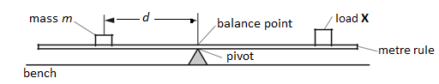

**Figure 1**

1. It is required that the load, X, should be fixed at the 90.0 cm mark of the metre rule and that the metre rule should balance horizontally by pivoting it at the 50.0 cm mark. Given a mass, m = 40 g, determine the distance d. Repeat the procedure for mass, m = 50, 60, 70 and 80 g and record your results in a suitable table, including values of $\frac{1}{d}$.
2. From the experiment described above, identify:
3. The independent variable.
4. The dependent variable.
5. The constant variable.
6. Plot a graph of m against $\frac{1}{d}$ and determine its slope, s.
7. Determine the mass µ, of the load **X** from the expression; $μ=\frac{s}{40}$.
8. (i) Comment on the constant value of 40 used in the expression for $μ$.
9. State the principle used in this experiment.
10. A heater coil is connected in series with a light bulb and a battery as shown in Figure 2. The coil is fully immersed in a beaker of water.

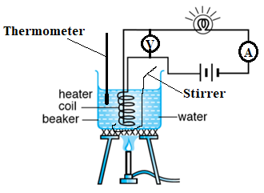

**Figure 2**

It is observed that the brightness of the lamp progressively decreases as the water is being heated. Based on the above information;

1. Suggest a suitable title for this experiment.
2. State one suitable hypothesis that could be investigated.
3. With the apparatus provided, connect the experimental arrangement shown in Figure 2. Stir steadily to ensure uniform temperature distribution in the water.
4. For the reading, θ, of the thermometer equal to 30 oC, read and record the voltmeter reading, V, and the ammeter reading, I.
5. Repeat procedure (d) for θ = 35, 40, 50, 60 and 70 oC.
6. Tabulate your results and include values of $\frac{V}{I}$.
7. From the experiment you have just carried out, state;
   1. The aim of the experiment.
   2. The variables (independent, dependent and fixed) in the experiment.
8. Plot a graph of θ against $\frac{V}{I}$.
9. From the graph,
10. Explain the physical meaning of the ratio $\frac{V}{I}$.
11. Comment on the relationship between θ and $\frac{V}{I}$.
12. Concave mirrors are widely used in optical systems. However, it is necessary to determine focal length f, of a concave mirror before its use.
13. A concave mirror is placed in a holder and used to focus light from a window onto a screen. The screen is adjusted until a sharp image is formed on it.
14. Measure and record the distance y, between the screen and mirror.
15. Explain the meaning of distance y
16. Arrange the mirror, mounted bulb and screen as shown in Figure 3. Adjust the distance U to 45cm and obtain an image on the screen. Adjust the screen until a sharp image of the object is obtained on the screen.

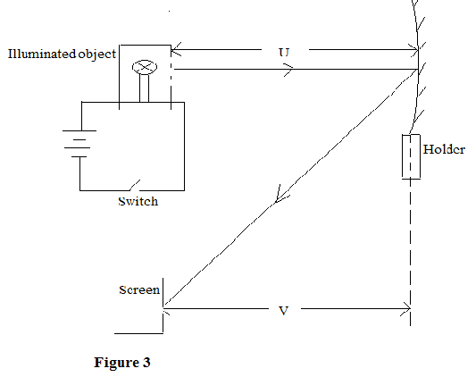

1. Measure and record the distance V.
2. Repeat the procedure for distance, U = 40, 35, 30, 25 and 20 cm.
3. Record your results in a suitable table, including values of $\left(U+V\right)and UV$
4. From the experiment described above identify; the
5. the independent variable
6. the dependent variable
7. the constant variable.
8. i. Plot a graph of UV against $(U+V)$ and determine its slope, s.

ii.Comment on the values of the slope s and y.

1. What are the likely sources of error in this investigation?

*END*

## 5.4 Physics Marking guide for Paper 2 (practical paper)

|  |  |  |  |
| --- | --- | --- | --- |
| **Question** | | **Response** | **Scoring guide** |
| 1 | a | * 5 *d* values in cm (<50), recorded to 1 dp or 3 s.f (i.e 30.0, 24.0, 20.0, 17.1, 15.0)±1.0 cm * 1/*d* values correct to 2s.f | Score 1 mark for the unit of d  Score 1 mark each for the values of d if d<50 and decreasing  Score 1 mark for the unit of 1/d  Score 1 mark for each value of 1/d correct to 3 s.f  **Maximum= 12 mks** |
| b | * Independent variable is mass m * Dependent variable is distance d * Constant variable is moment of the load X | Score 1 mark each for correctly identifying the variables  **Maximum = 3 marks** |
| c | **Graph**:   * axes labeled with quantity and unit * scales suitable, plots occupying at least half grid * plots all correct to ½ square (take centre of plot if large) * well-judged thin line (≤ ½ square)   triangle method used and shown (any indication on graph) using at least half line (can be seen in calculation) | Score 1 mark for each axis labeled with units  Score 1 mark for each correct (usable) scale for each axis  Score 1 mark for each correctly plotted point  Score 1 mark for a well- judged line of fit  Score 1 mark for the indication of triangle for obtaining the slope  Score 1 mark for substituting the right values for obtaining the slope  Score 1 mark for the value of the slope  Score 1 mark for the unit of the slope  **Maximum = 14mks** |
| d | µ = 27 – 33 (g) to 2 or 3 signiﬁcant ﬁgures | Score 1 mark for proper substitution in expression  Score 1 mark for the value of µ  Score 1 mark for correct unit of µ  **Maximum = 3mks** |
| e | * The constant value of 40 is the distance from the load X to the pivot. * The principle used in the experiment states that when a body is in equilibrium, the sum of the clockwise moments acting on it will be equal to the sum of the anticlockwise moments acting on it | Score 1 mark for correctly identifying the constant 40/  Score 1 mark for correctly stating the principle used in the experiment  **Maximum = 2 marks** |
|  | f | Any one difficulty and solution from the following   |  |  | | --- | --- | | **Difficulty** | **Solution** | | rule won’t balance exactly | allowing to tip one way then the other and take average | | ﬁnding position of centre of the mass on the rule | marking centre of mass so it can be read against rule  OR take average of right hand and left hand readings for mass position | | mass slides on the ruler | suitable means for preventing mass sliding | | Score 1 mark for any one identified difficulty  Score 1 mark if the identified difficulty is provided with a relevant solution  **Maximum= 2 marks** |
| 2 | a | * Investigating the effect of temperature on the resistance of a conductor | Score 1 mark for correct title of the experiment.  **Maximum = 1 mark** |
|  | b | * Increase in temperature increases the resistance of a conductor | Score 1 mark for correct hypothesis for the experiment.  **Maximum = 1 mark** |
|  | f | * Columnar table with labels of θ(oC), V(V), I(A) and $\frac{V}{I}$ (Ω) * Values of V recorded to 2d.p, increasing. * Values of I recorded to 1d.p, decreasing. * Values of $\frac{V}{I}$ to 2d.p, increasing. | Score 1 mark each for the correct label and unit of the columns of table of results.  Score 1 mark for each value of V correctly recorded  Score 1 mark for each value of I correctly recorded  Score 1 mark for each value of $\frac{V}{I}$ correctly recorded  **Maximum = 19 marks** |
|  | g | 1. To investigate the effect of temperature on the resistance of a conductor. 2. Independent variable – Temperature; Dependent variable – Current and voltage;   Constant variable – emf of the cell. | Score 1 mark for correct title.  Score 1 mark for each variable correctly stated  **Maximum = 4 marks** |
|  | h | * Title of graph; A graph of θ against $\frac{V}{I}$. * Vertical axis labeled θ (oC) and horizontal axis labeled $\frac{V}{I}$ (Ω). * Correctly plotted points and indication of line of best fit | Score 1 mark for correct title of graph.  Score 1 mark for each point correctly plotted on the graph  Score 1 mk for correctly indicating line of best fit  **Maximum = 7 marks** |
|  | i | 1. is the resistance of the heating element. 2. As values of θ increases, the value of $\frac{V}{I}$ also increases. | Score 1 mark for correctly interpreting the meaning of $\frac{V}{I}$.  Score 1 mark for correctly stating the relation between θ and $\frac{V}{I}$.  **Maximum = 2 marks** |
| 3 | a | 1. The value of y in cm | Score 1 mark for the value of y if units are stated. Reject if unit is missing |
|  |  | 1. This is approximately the focal length of the mirror. The point of the sharpest image is the principal focus | Score 1 mark for the meaning and 1 mark for the interpretation |
|  | b | * Columnar table with labels of U(cm), V(cm), (U+V)(cm) and UV(cm2) * Values of V recorded to 1d.p, decreasing. * Values of U+V recorded to 1d.p, decreasing. * Values of UV to 1d.p, decreasing. | Score 1 mark each for the correct label and unit of the columns of table of results.  Score 1 mark for each value of V correctly recorded  Score 1 mark for each value of U+V correctly recorded  Score 1 mark for each value of UV correctly recorded |
|  | c | 1. Independent variable – object distance U | Score 1 mark for correct identification |
|  |  | (ii) Dependent variable – image distance V | Score 1 mark for correct identification |
|  |  | (iii) Constant variable – focal length | Score 1 mark for correct identification |
|  | d | * Title of graph; A graph of UV against (U+V) * Vertical axis labeled UV (cm2) and horizontal axis labeled (U+V) (cm) * Correctly plotted points * indication of line of best fit * correctly indicating the triangle for calculating the slope | Score 1 mark for correct title of graph.  score 1 mark each foe correct labeling of axes  Score 1 mark for each point correctly plotted on the graph  Score 1 mark for correctly indicating line of best fit  Score 1 mark for the indication of triangle for obtaining the slope  Score 1 mark for substituting the right values for obtaining the slope  Score 1 mark for the value of the slope  Score 1 mark for the unit of the slope |
|  |  | 1. The slope is equal /approximately equal to y. Hence the slope is the focal length of the mirror | Score 1 mark for proper statement  Score 1mark for the comparison |
|  | e | * Poor/inappropriate positioning of object * Inability to locate sharp image | Score 1 mark each for the possible sources of errors up to a maximum of any two. |

*END*